SECTION 1 — Team Information
Field | Response
Team Name | CS309
Project Title | AI Recommender Tool
Semester | Spring 2026
Students | Kelly Hwangpo, hwangpoks, hwangpoks@vcu.edu  Jake Carduck, carduckj, carduckj@vcu.edu  Michelle Koh, kohme, kohme@vcu.edu  Dylan Tran, trandn3, trandn3@vcu.edu
Team Communication Channel | (Slack / Discord / WhatsApp / Teams / Email / Other)
Repository / File Sharing Tool | (GitHub / Drive / Notion / Other)

SECTION 2 — Advisor Information
Field | Response
Faculty Advisor Name | Caroline Budwell
Advisor Email | ccbudwell@vcu.edu
Advisor Meeting Frequency | (Weekly / Biweekly / Monthly / Other)
Last Advisor Meeting | Date or “Not yet”
Planned Meeting Day/Time | Monday, 2-3PM
Sponsor (If Applicable) | Lakshmi Narayana Rasalay, Capital One  Nabin Debnath, Capital One
Sponsor Contact Email | LakshmiNarayana.rasalay@capitalone.com  nabin.debnath@capitalone.com

SECTION 3 — Fall Status Review
Check all that apply:
Documents Completed in Fall (CMSC 451):
□ Proposal
□ Preliminary Design Report (PDR)
□ Poster Draft
□ Design Diagrams
□ Requirements Document
□ Architecture Diagram
□ None Completed
Upload links (optional if already submitted previously):
Proposal Link: _https://docs.google.com/document/d/1888FtKfDiwHYDaa7PoqKLmUUF7wOWKmv/edit#heading=h.embnt12avbat_
PDR Link: _https://docs.google.com/document/d/1888FtKfDiwHYDaa7PoqKLmUUF7wOWKmv/edit#heading=h.embnt12avbat__
Poster Draft Link: _https://drive.google.com/file/d/1tA7IYTNfoM1WG57vM1H6GO-r73p6q8Mt/view?usp=sharing_
Technical Status:
Current Build Status (select one):
□ No implementation started
□ Proof-of-Concept / Prototype
□ Partial system working
□ Fully functional system
□ Hardware-dependent (explain)
Notes: __________________________________
Repository Status:
Repository Link: __https://github.com/VCU-CS-SeniorDesign/senior-design-project-repository-cs-309__
Private / Public? □ Private □ Public

SECTION 4 — Technology & Dependencies
List all major technologies planned for Spring:
Languages: __CSS, JavaScript, Java, HTML, Typescript_
Frameworks: __React__
Databases: _Astra__
Hardware: __N/A__
APIs / Integrations: __Google AI Studio__
Other Dependencies: __N/A__

SECTION 5 — Expo Preparation Risk Indicators
Please mark any that apply:
□ Team member missing / inactive
□ Advisor alignment unclear
□ Scope still changing
□ Sponsor unavailable / unresponsive
□ Technical blockers expected
□ Hardware delays expected
□ Unsure about Expo expectations
□ Unsure about Final Report expectations
□ No identified risks
If any checked, explain:
- Lack of response to discord messages
- Problems involving AI and APIs working
- Need more detail for Expo expectations (Uncertainty)

SECTION 6 — Advisor Confirmation
Advisor must acknowledge awareness of Spring continuation.
Advisor Confirmation Method (choose one):
□ Email Confirmation Attached
□ Advisor Signed Below
□ Pending (must be completed by Week 2)
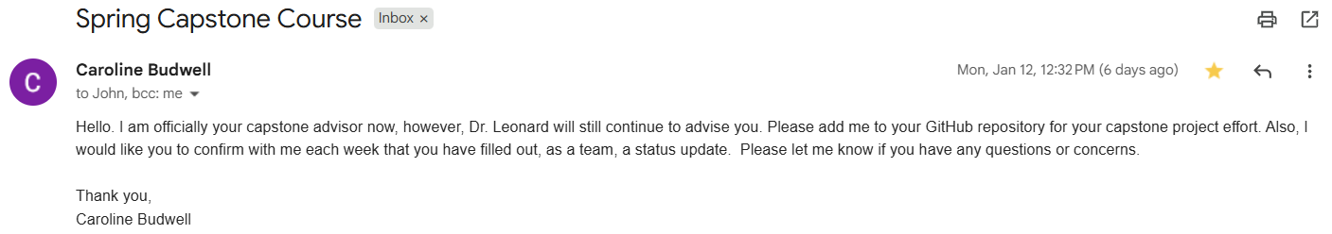
Advisor Signature (optional): ___________________
Date: _____________

SECTION 7 — Certification
By submitting, the team confirms:
✔ Advisor is aware of continuation into Spring
✔ All team members reviewed Spring deliverables
✔ Expo expectations are understood
✔ Weekly reporting will be submitted
Submitted by: _Kelly Hwangpo_ (Team Representative)
Date: __01.18.26__

